|  |  |  |  |  |
| --- | --- | --- | --- | --- |
|  |  |  |  |  |
|  |  |  |  |  |
|  |  |  |  |  |
|  |  |  |  |  |
|  |  |  |  |  |
|  |  |  | [Event Title Here]  [Type a tagline for your event here.] |  |
|  |  |  |  |  |

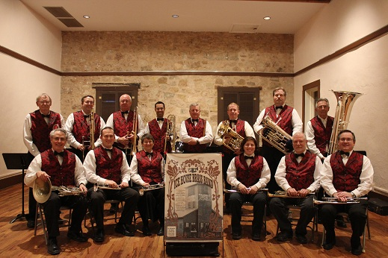

|  |  |  |  |  |
| --- | --- | --- | --- | --- |
| |  | | --- | | Ice House BRASS Band is coming to the  **Carnegie Library**    Mary **Sykes** Auditorium  **204 n. 8th Street**  **Ballinger, Texas**  **October 24, 2015**  **3:00 in the afternoon**  October 24 3 PM | |  | | C | |  |